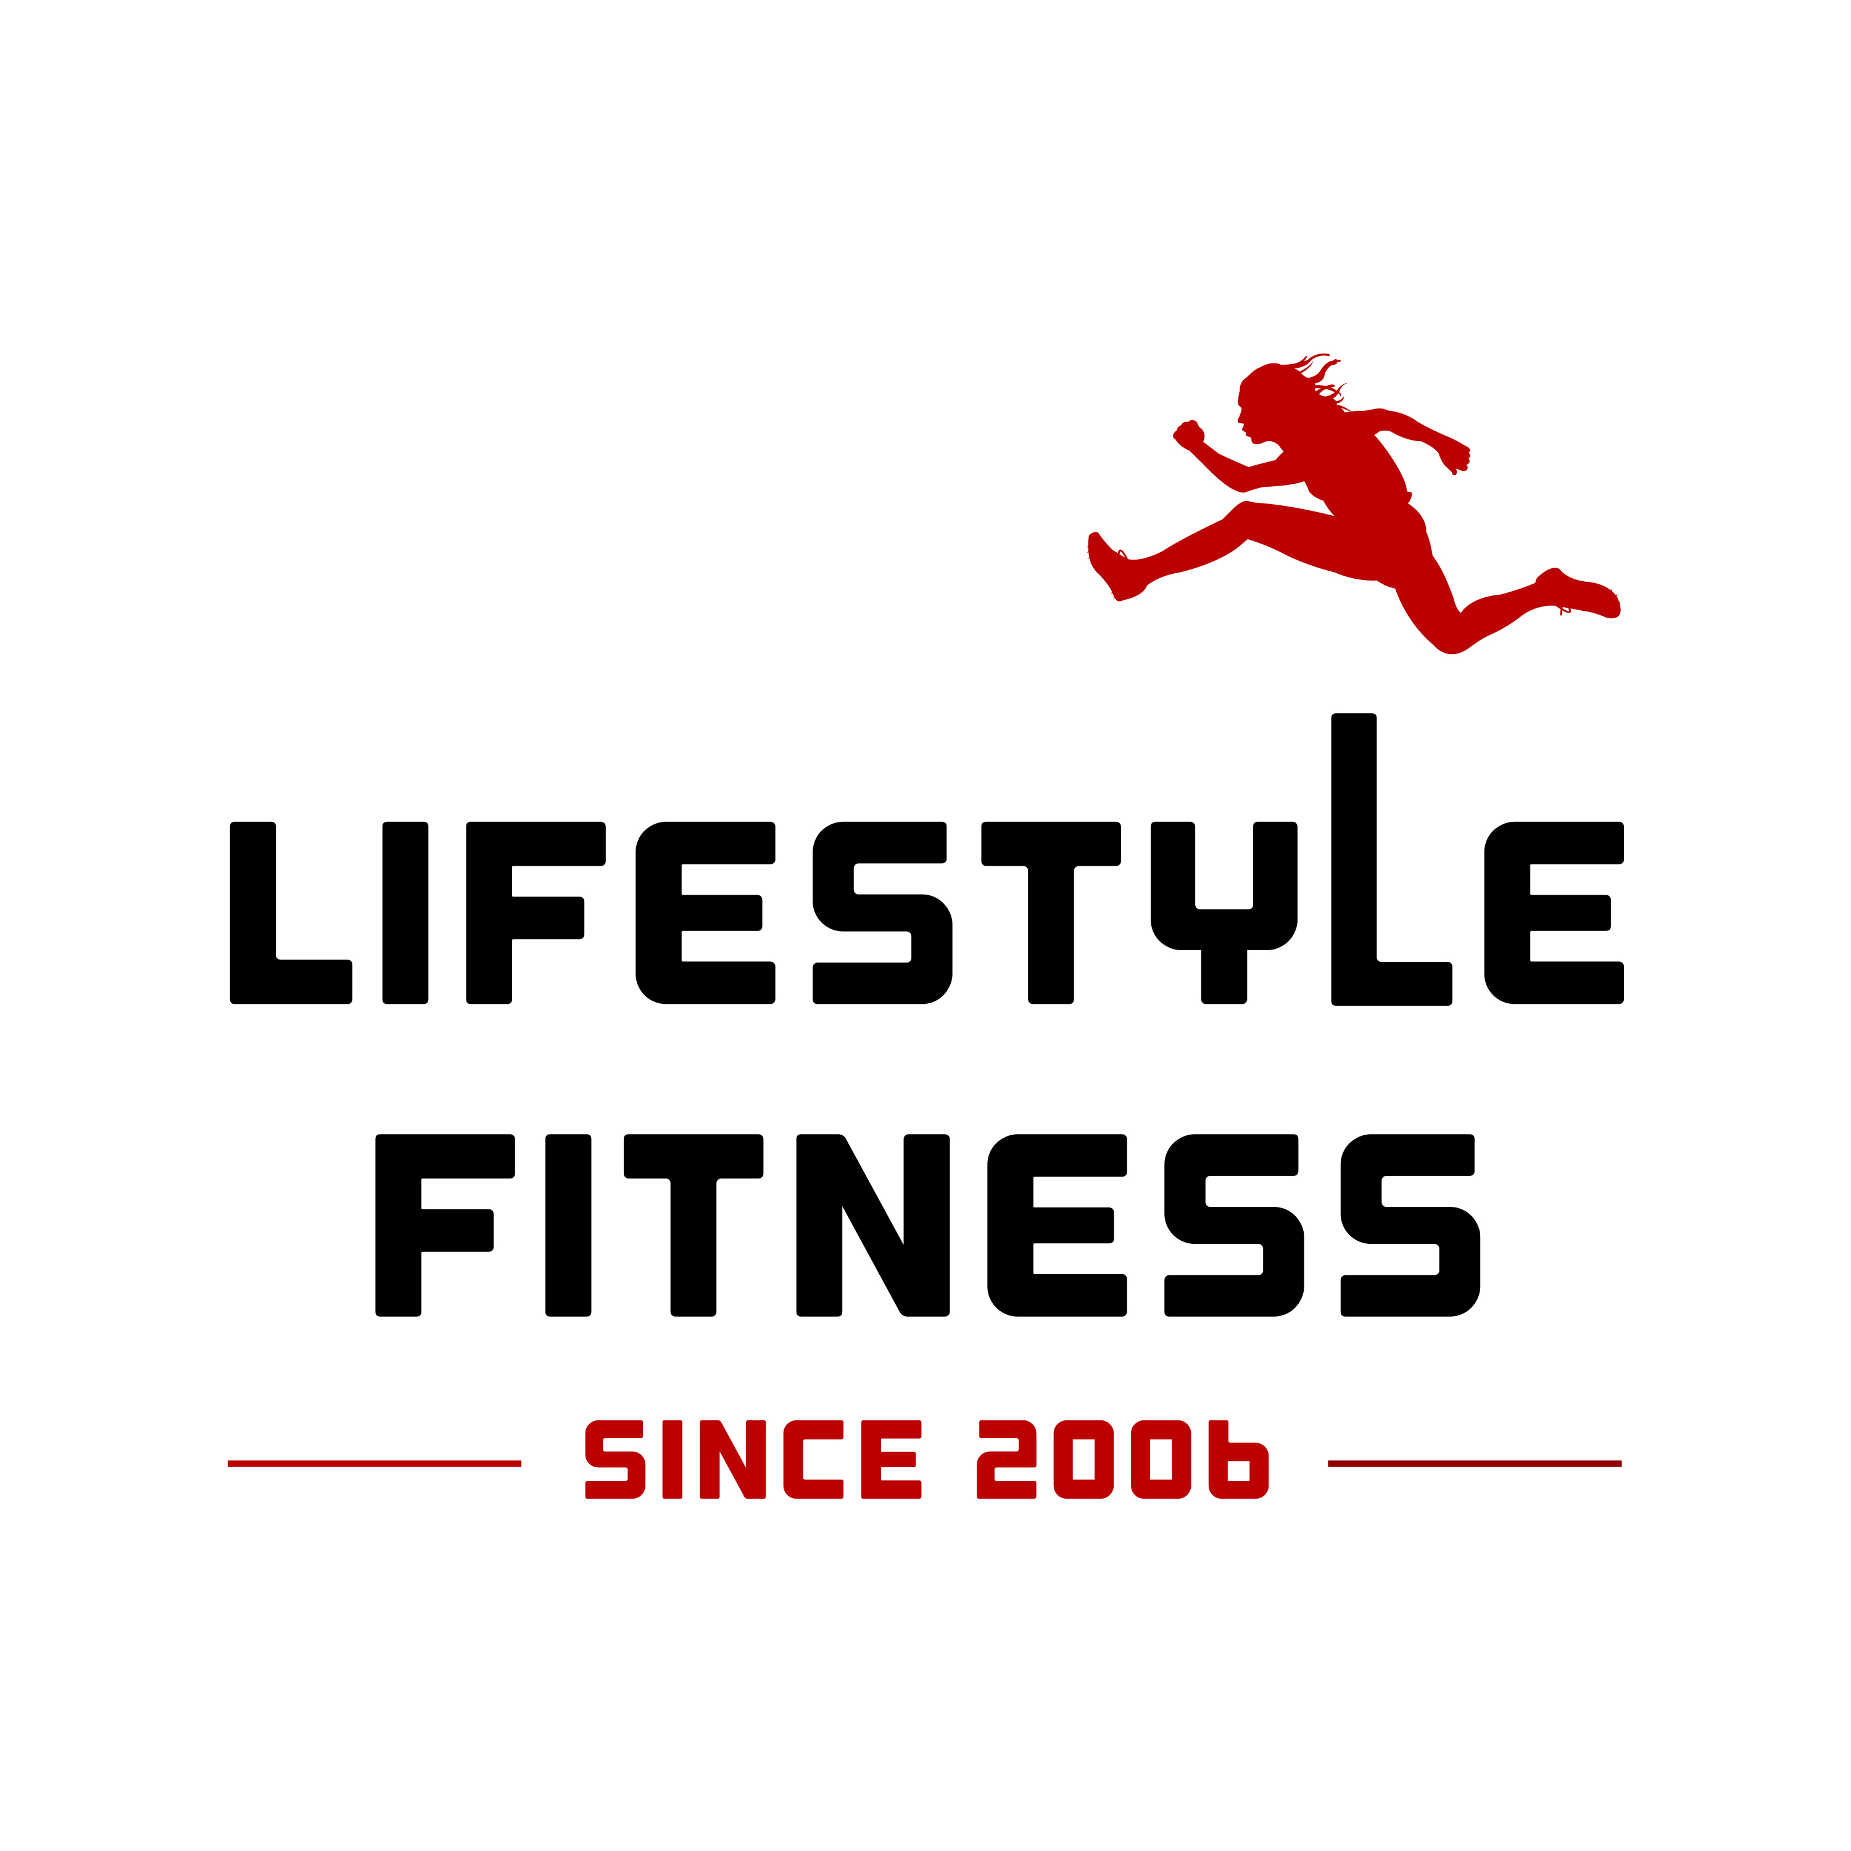

PAR-Q

A Physical Activity Readiness Questionnaire for People Aged 15 to 69

Regular physical activity is fun and healthy. More people are becoming active every day. Being more active is very safe for most people, however people should check with their doctor before they start becoming much more physically active. If you are between the ages of 15 to 69, the Par-Q will tell you if you should check with your doctor before you start. If you are over 69 years of age, and you are not used to being very active, check with your doctor.

Common sense is your best guide when you answer these questions. Please read the questions carefully and answer each one honestly. Check YES or NO

YES NO
1. Has your doctor ever indicated that you have a heart condition and that you should only do physical activity recommended by a doctor?

2. Do you feel pain in your chest when you do physical activity?

3. In the past month, have you had chest pain when you were not doing physical activity?

4. Do you lose your balance because of dizziness or do you ever lose consciousness?

5. Do you have a bone or joint problem (for example, back, neck, knee, or hip) that could be made worse by a change in your physical activity?

6. Is your doctor currently prescribing drugs (for example, water pills) for your blood pressure or heart condition?

7. Do you have Insulin Dependent Diabetes?

8. If female, are you pregnant ?

9. Do you know any other reason why you should not do physical activity?

Informed use of the PAR-Q: Lifestyle Fitness assumes no liability for persons who undertake physical activity. If you are in doubt after completion of this questionnaire, Please contact Lifestyle Fitness ( 831-663-3529 or email us at : LifestyleFitnessPrunedale@Gmail.com) and consult your doctor prior to physical activity.

NOTE: If the PAR-Q is being given to a person before he or she participates in a physical activity program or a fitness assessment, this section may be used for legal or administrative purposes.

“I have read, understood and honestly completed this questionnaire. Any questions I had were answered to my full satisfaction.”

NAME: _____________________________________________________________________________

SIGNATURE: ________________________________________________________________________

SIGNATURE OF PARENT: _____________________________________________________________

DATE: : _________________________________

PAR-Q

A Physical Activity Readiness Questionnaire for People Aged 15 to 69

If you answered YES to one or more questions:

• Please contact Lifestyle Fitness ( Call us at : 831-663-3529. Or email us at : LifestyleFitnessPrunedale@gGmail.com) prior to your scheduled class/private session. We may need to reschedule your appointment until you speak with your Doctor. We may also require your Physician to fill out a medical release form ( we will provide form) before we can continue with your assessment and training program. Your health and safety is our top priority.

• If you are or trying to become pregnant, Please inform Lifestyle Fitness and your Physician. Modifications to your program maybe advised by your Physician/OBGYN.

If you answered NO to all questions:

˙ If you answered NO honestly to all PAR-Q questions, you can be reasonably sure that you can participate in a physical assessment and training program. Physical assessment will be used to create a program intensity that is safe and beneficial for your current physical activity level.

PLEASE NOTE: If your health changes to YES to any of the above questions, please inform Lifestyle Fitness and your Physician.

NAME: _____________________________________________________________________________

SIGNATURE: ________________________________________________________________________

SIGNATURE OF PARENT: _____________________________________________________________

DATE : ________________________

WITNESS:____________________________________________________________________________

NOTE: This physical activity clearance is valid for a maximum of 12 months from the date it is completed and becomes invalid if your condition changes so that you would answer YES to any of the nine questions.

